

Joylan E. Panungcat

Jay-art R. Sabandal

Luz Clarisse E. Pejera

BSIT-4A

IT411 – System Integration and Architecture

1. Create and describe the UML Use Case Diagram of an ATM system

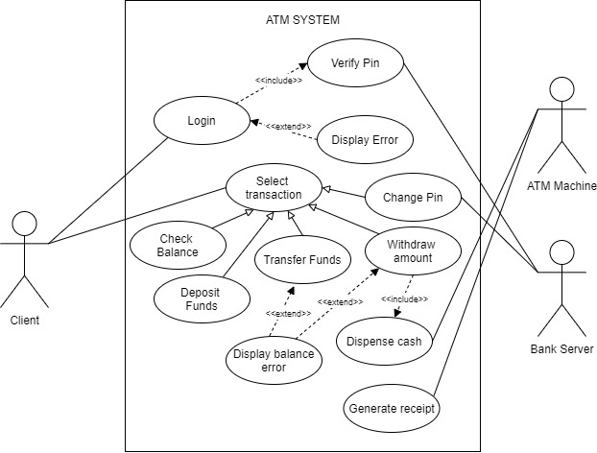

This flow describes how an ATM system works using the UML Use Case Diagram as a guide for the process. This system has two actors primary and secondary, the left side basically the primary actor in which it initiates the use of the atm system and the right side is a secondary actor it is more on reactionary. This process have different use cases it includes; login with two relationship, include and extend for Verify Pin and Display Error, also Select transaction with five different generalization relationship includes Check Balance, Deposit Funds, Transfer Funds, Withdraw amount, Change Pin. The Display balance error use case extended in both Transfer Funds and Withdraw amount. The Dispense cash in included by withdraw amount and the last one is Generate receipt. The process of these system is discuss as follow;

First, the client’s login and the bank server will verify, after verification if no error client can select different transaction including check balance, deposit funds, transfer funds, withdraw amount and change pin. If client withdraw amount the ATM Machine will dispense cash if no error in amount balance and generate receipt.

1. Create and describe the UML State Diagram of a Flight Booking

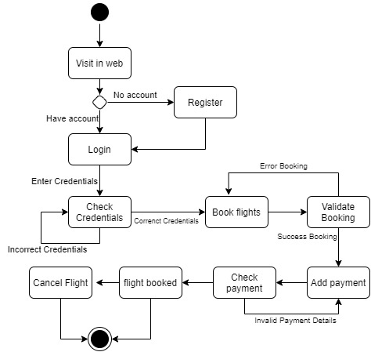

This is the UML State Diagram of a flight booking. The process describe on how the system works. First, the solid black circle indicates the starting point, then the transition move to visit in web then move to the diamond shapes, this represents as a condition if you already have an account, if no account the transition will move to Register and after registration will proceed to login. After checking all the input credentials, if the details is incorrect the Check credentials states will loop and if it is correct we book flights and the transition will move to validate booking after booking validation then proceed to add payment. After adding payment if no error the flight will successfully booked. The solid black bordered circle will indicates the end of the process.

1. Create and describe the UML Sequence Diagram of an Hotel Reservation

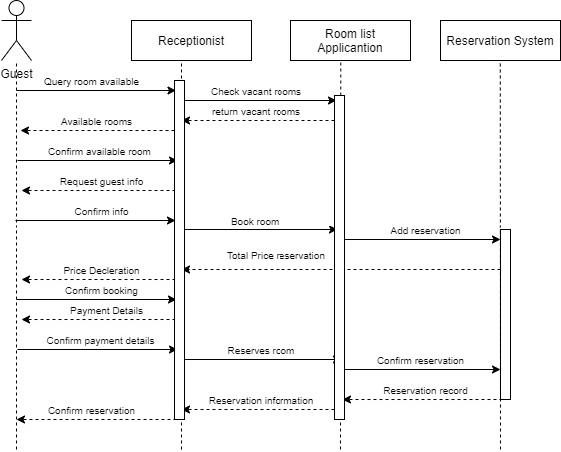

This flow here describes how a Hotel reservation system works using the UML Sequence Diagram as a guide for the process. The shown diagram illustrates the whole process on how Hotel Reservation functions by showing example objects as well as messages that are relayed through each objects. The human stick symbol represent the actor and the rectangle represent as the object. First, the guest send the message or asking for an available rooms (the solid forward arrow represent the send message) to the receptionist and the receptionist check vacant rooms in the Room lost application object, then the room list object replies to the earlier message (The dashed line represents a return message).

After checking the available rooms the receptionist will ask for the guest details for the room reservation and the guest will confirm the room for reservation, after confirming the reservation will added to the reservation system object, then return message for the total price reservation and the receptionist asking for a payment, then the guest will confirm and sent the payment details. After the transaction, the receptionist will confirm the reservation with the client.